Agency Name

INFORMATION TECHNOLOGY PLAN FY 2021 - 2023

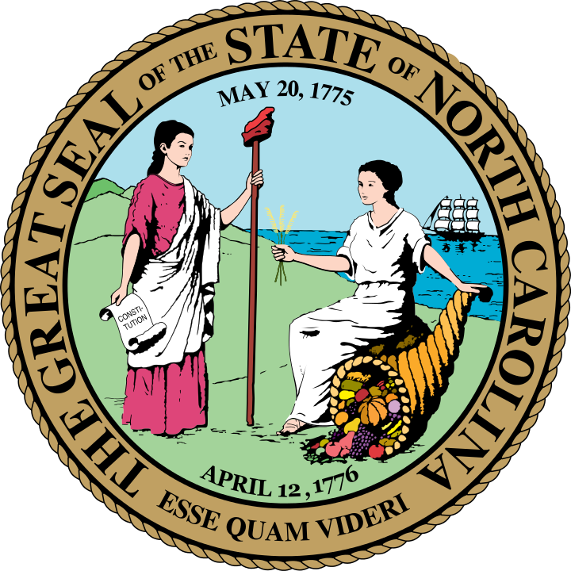

By
Agency CIO, Agency Name

This page left blank intentionally

Contents
1. Instructions Error! Bookmark not defined.
2. Statewide Information Technology Goals 1
3. (Insert Agency Name) Strategic Plan Executive Summary and Goals 2
4. (Insert Agency Name) IT Plan Initiative Table 3
5. (Insert Agency Name) IT Program, Project, or Initiative Justifications 4
6. (Insert Agency Name) Enterprise IT Opportunities 5
Appendix A: (Insert Agency Name) IT Organizational Chart 6
Appendix B: (Insert Agency Name) IT Accomplishments and Progress Review 7

This page left blank intentionally

Statewide Information Technology Goals
Below are the statewide IT goals for the 2021-2023 biennium.
1. Secure IT systems and infrastructure: Provide a resilient infrastructure that mitigates risk, supports business continuity, provides security and privacy of the state’s and citizens’ data, and supports secure collaboration and information sharing.
2. Deepen trusted partnerships: Support and empower the business of state government by improving processes, enhancing cross-agency collaboration and cooperation, and establishing and managing IT standards.
3. Improve the management and transparency of IT: Improve the usage of the state’s IT resources by increasing the visibility into those, the cost of the resources, and their overall utilization.
4. Modernize and centralize IT operations: Through process improvement and optimization, modernize and centralize technology operations to effectively support a 21st century government.
5. Empower our citizens through technology: Provide transparent, easy-to-use, and customer-focused government and student services.
6. Promote better decision-making through analytics: Leverage the state’s data to make more informed decisions, policies, and laws.
7. Operation Efficiency: Eliminate redundancy of systems, services, and technologies to streamline operations.

(Insert Agency Name) Strategic Plan Executive Summary and Goals
Include a high-level summary of your agency’s strategic plan, including goals and objectives, here.

(Insert Agency Name) IT Plan Initiative Table
In the table below, please outline your IT programs, projects, or initiatives. Include whether it is new, a brief description, the required budget, how it will be funded, what agency and/or statewide IT goal it supports, and when you expect it to be completed.
 | IT Program, Project, or Initiative | New  (Yes/No) | Description  *Provide Justification in Section 4 | Budget Requirement ($) | Funding Mechanism | Supported Agency Goal | Supported Statewide IT Goal | Anticipated Completion Date
1
2
3
4

(Insert Agency Name) IT Program, Project, or Initiative Justifications
Provide a detailed narrative for each item from the table in Section 3. Explain how the program/project/initiative directly supports an agency and/or SCIO strategic goal and how you intend to measure progress.

Below is an example. Please follow this format.
- Project A
  - Justification: Explain in more detail what Project A entails, specifically documenting how Project A will support statewide IT goal 5 (to modernize and centralize IT operations).
  - Measures: Explain how you will measure the progress/success of Project A towards achieving statewide IT goal 5.

(Insert Agency Name) Enterprise IT Opportunities
The purpose of this section is to learn about additional initiatives that your agency envisions, possible joint funding opportunities that the agency may be planning with other agencies, and other funding sources that could be utilized at the enterprise level. Please consider both IT and non-IT initiatives. Most initiatives that are enterprise in nature will likely require both business and IT resources.
5.1. Potential Initiatives
Describe any additional initiatives that your agency envisions and would like to take on but does not currently have the resources to undertake.
5.2. Collaborative Opportunities
Identify opportunities for statewide or inter-agency collaborative initiatives that would yield significant efficiencies or improve effectiveness in State programs.

Appendix A: (Insert Agency Name) IT Organizational Chart
Please insert your current organizational chart.

Appendix B: (Insert Agency Name) IT Accomplishments and Progress Review
Please update the table below with progress from your 2019-21 IT Plan. Please note whether the initiative is completed, underway, in planning, or no longer relevant.
FY19-21 Goal | FY19-21 Objective | FY19-21 Initiative | Progress  Review | Anticipated  Completion Date
Goal 1 | Objective 1.1 | Initiative 1.1.1
 |  | Initiative 1.1.2
 | Objective 1.2 | Initiative 1.2.1
 |  | Initiative 1.2.2
Goal 2 | Objective 2.1 | Initiative 2.1.1
 |  | Initiative 2.1.2
 | Objective 2.2 | Initiative 2.2.1
 |  | Initiative 2.2.2
Goal 3

