SYSTEMWARE CONTENT CLOUD
Report Viewing/Downloading/Printing

Enter the below URL –

https://enteryouraddresshere.com

NOTE: If using Internet Explorer, you can save this URL as a Favorite by clicking on the yellow star icon (left hand side of tool bar). You will then be able to click on that link () rather than entering the URL.

[IMAGE OF TOOLBAR BEFORE ADDING FAVORITE]

Toolbar after adding URL as a favorite -

[IMAGE OF TOOLBAR AFTER ADDING FAVORITE]

+++++++++
NOTE: If using Google Chrome, you can Bookmark this URL by hitting Enter and then clicking on the icon (far right), hovering over Bookmarks and then clicking Bookmark this page; or by clicking the icon at the right end of the URL line.

[IMAGE OF TOOLBAR BEFORE ADDING FAVORITE]

Toolbar after Bookmarking URL -

[IMAGE OF TOOLBAR AFTER ADDING FAVORITE]

Enter your userID/password then hit Enter

NOTE: You must have a _________ userID

[IMAGE OF LOGON PANEL]

You are now logged into Systemware Content Cloud with the Welcome page displayed.

NOTE: You can change your ‘First Page’. See procedures below.

NOTE: Toolbar options may vary based on level of access.

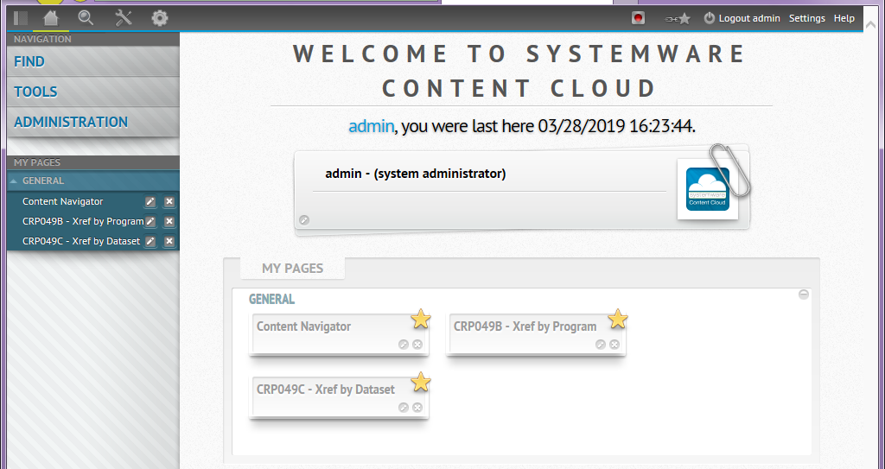

NOTE:

[THIS AREA WOULD BE GOOD FOR GENERAL INFORMATION IN REGARDS TO OBTAINING ACCESS, ID’S, ETC]
General Comments –

At any time, you may click the large olive green circle with arrow (upper left side of window) to go back a Navigation panel.

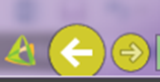

There is a green bar that will move across the top of your page. This is an indication that your request is being processed.

You can hover over the icons on the toolbars to see what options are available.

Clicking on the Toggle Left Panel icon (1st icon on toolbar) will eliminate the Navigation pane.
Clicking again will restore the pane.

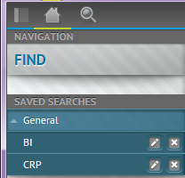

If you have closed a report from Show Versions and want to view a different report, click on Content Navigator on the toolbar to return to the Document Properties pane.

You can hover over Help (upper right side of window) on any page and get more information about the page you are on

[IMAGE OF HELP BUTTON IN TOP RIGHT CORNER]

Click on x (upper right side of window) to exit Help

Example of Help page -

[IMAGE OF A HELP PAGE]

Accessing Reports –

Click FIND (if not expanded) then click Content Navigator -

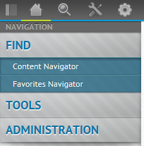

or

Hover over the Magnifying Glass then click Content Navigator -

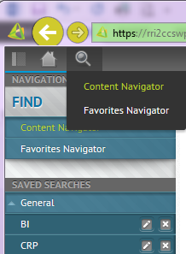

You will be presented with this window -

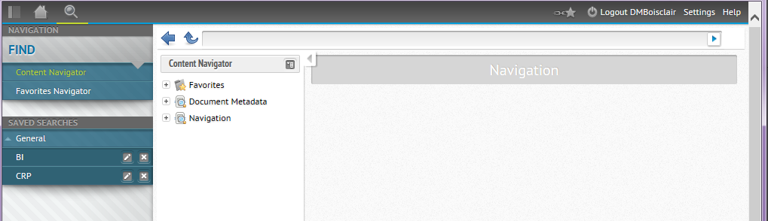

Click on the box to the right of Content Navigator (2nd column/pane) then click Find All Content by Report -

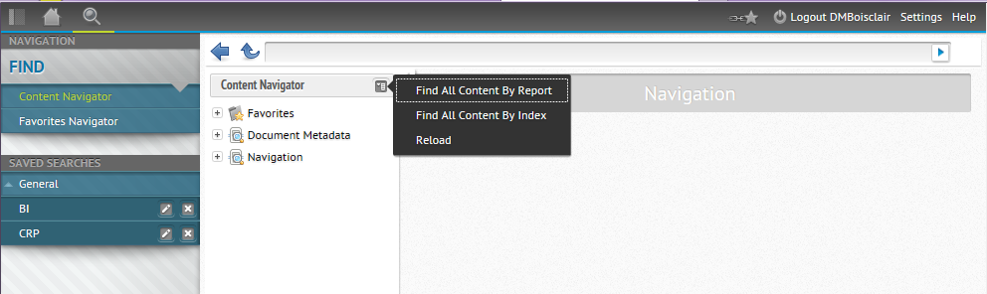
You are now presented with the Document Properties window and can access reports as you prefer –

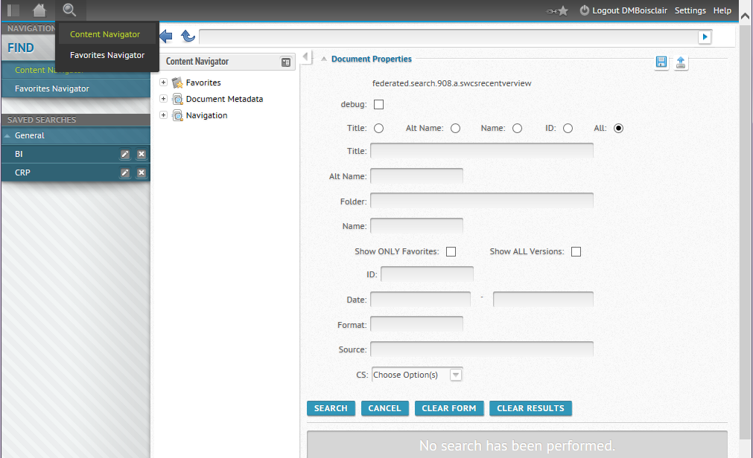

If you want a larger Document Properties window you can click on the gray arrow which will hide the Content Navigator pane. You can also click on Toggle Left Panel icon (upper left hand corner) which will hide the Navigator pane.

Clicking on the Toggle Left Panel icon (upper left hand of screen) will restore the Navigator pane.

Clicking on the gray arrow 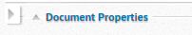 (upper left hand of screen) will restore the Content Navigator pane.

Options:

Click SEARCH and it will list all reports you have access to.

NOTE: You can change the Results Per Page by clicking on the down arrow and selecting the number of items to display. The higher the number the longer the Search will take. You will also see how many items met your search criteria.

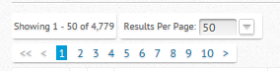

Click CLEAR RESULTS to begin a new search.

You can change your search window by selecting a specific access method or select All to see all options.

NOTE: Search criteria values are not case sensitive.

If you know which reportID you want, you may enter the reportID in Alt Name or enter any portion of the reportID and click SEARCH. You will be presented with a list of reports meeting the search criteria.

If you know a word in the title, you can enter the word(s) in Title and click SEARCH.

If you only want to view reports created on a certain date or between certain dates, you can click the Date boxes and click on the appropriate date(s) and click SEARCH.

If you want to see all reports created by a certain job, enter the jobname in Source and check Show ALL Versions then click SEARCH.

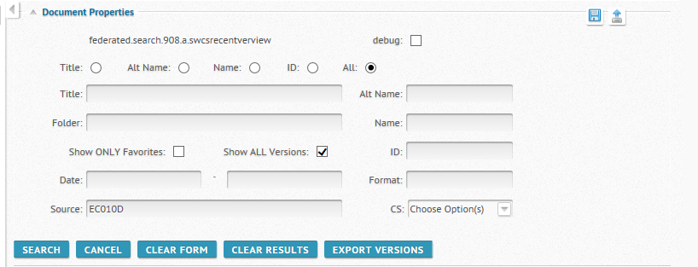

If you have a search criteria that you do often, you can do a Save Search by clicking on the 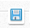 icon which will open the below Save Search window. Enter a Name for your search and click Save. To Load a Saved Search, click the icon which will open the below Load Search window. Click on the Name drop down menu to select your search and click Load.

NOTE: Saved Searches will appear in the Navigator pane.

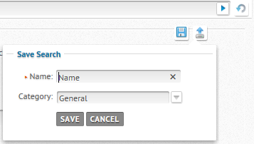
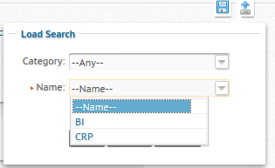

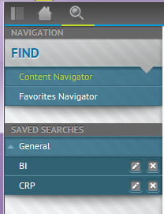

Result of clicking Search –

NOTE: Clicking on the column heading(s) will allow you to sort your list.

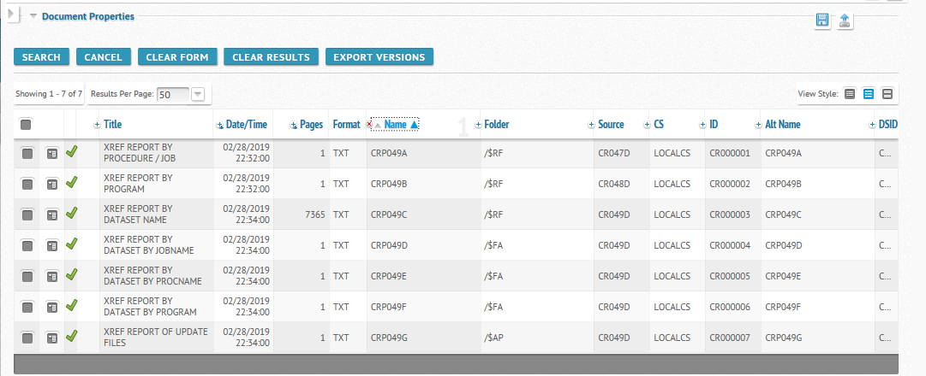

You can double click on a report to open the most current version for viewing or click on the Show Menu box in the 2nd column to display a list of options.
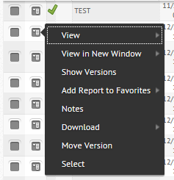

Click View to open most current version in either TXT or PDF format

Click Show Versions to see all available versions
You can double click on the version you want to open for viewing or click on the Show Menu box in the 2nd column to open up a list of options available

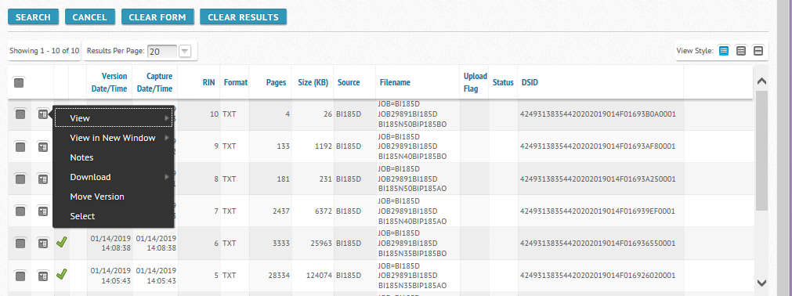

Toolbar -

When viewing a report in TXT format, a new toolbar will appear giving you different options – you can hover over the icons to see what each one is for

View in New Window –

If you would like to compare reports or reference multiple reports, you can select View in New Window which will open the report in a new window and allow to manage the windows as you want.

[IMAGE OF TWO REPORTS OPEN IN SEPARATE WINDOWS]

Add Report to Favorites –

You can create a My Favorites list of reports by clicking on the box in the 2nd column to open up a list of options available – hover over Add Report to Favorites and click General. The report will now appear under My Favorites in the Favorites Navigator pane.

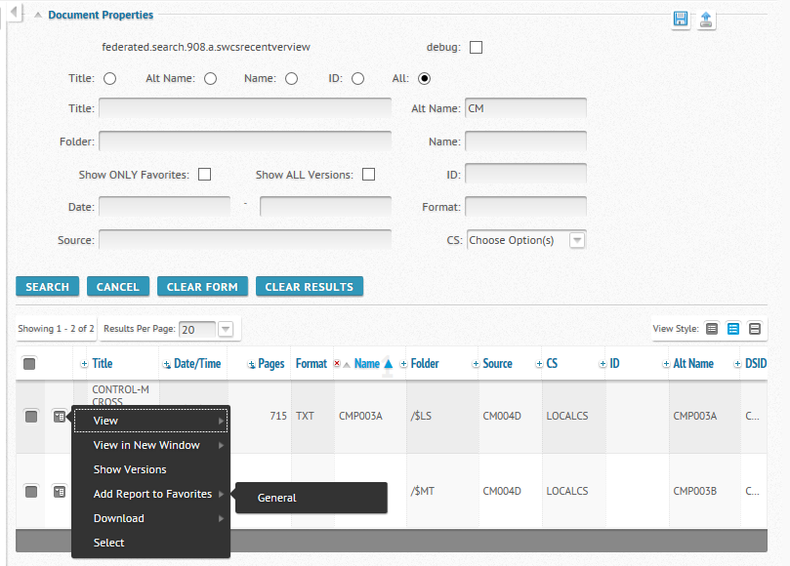

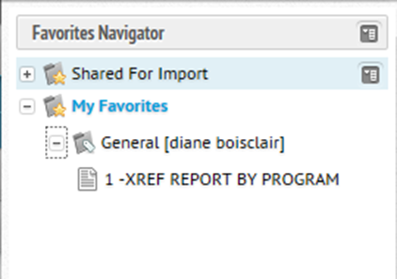

If you hover over the report under My Favorites – General, you will see a box appear. Click to display a list of available options.

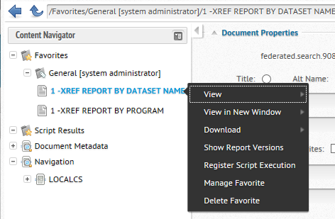

Click Delete Favorite to remove report from your My Favorite navigator.

Query Indexed / Text Field (availabe when viewing report in TXT format) –

NOTE: You can check to see which fields are indexed by clicking on the Down Arrow to the right of JOBA$. If you feel you would benefit by having the report indexed, send an EMAIL to the ProductionControl mailbox to make your request.

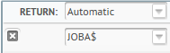

NOTE: If the report has no indexed fields, you will see –Text – in the box.

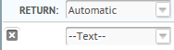
The Actions Menu icon 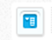 on the toolbar (upper left hand corner) will give you an option to Query.

Click on the icon – hover over Query – click on Content Query –

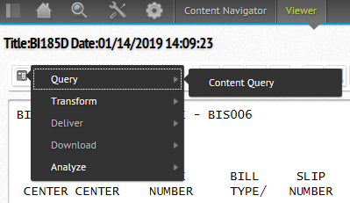

You will be presented with a Content Query box

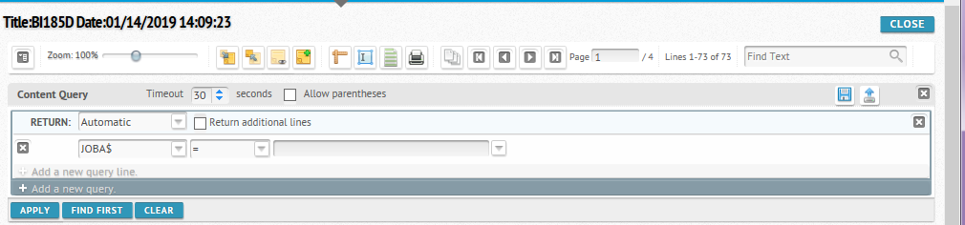

Click on the drop down menus to select the criteria of your query then click Apply or hit Enter

NOTE: You may add additional criteria by clicking the + Add a new query

[IMAGE OF A CONTENT QUERY AFTER SUBMITTED (clicked APPLY)]

If you select – Text – the box will expand to enable you to search for text between specific columns/lines

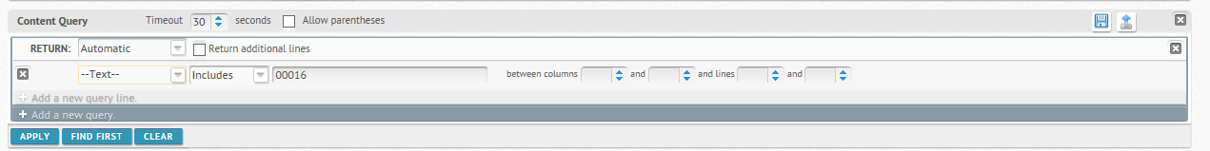

If you have a query criteria that you do often, you can do a Save Content Query by clicking on the icon 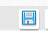 on the right of the Content Query box which will open the below Save Content Query window. Enter a Name for your query and click Save. To Load a saved Content Query, click the icon on the right of the Content Query box which will open the below Load Content Query window. Click on the Name drop down menu to select your query and click Load.

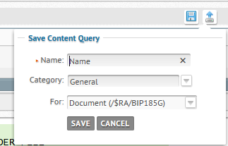

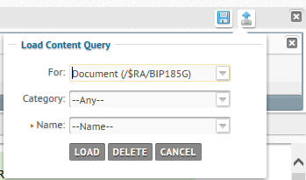

Downloading/Printing a Report -

The Actions Menu icon 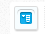on the toolbar (upper left hand corner) will give you an option to download the report to your desktop. If you hover over Download you will see that you can download a TXT or PDF file.

NOTE: [INSERT SPECIFIC NOTES HERE REGARDING YOUR PRINTING REQUIREMENTS, STANDARDS, COMPANY INITIATIVES TO REDUCE PRINT, ETC]

NOTE: [THE FOLLOWING MAY BE APPLICABLE TO YOUR COMPANY] If you want to print the report as a report, select PDF so you have the proper page breaks. You will be printing the report on your network printer. There are limits to size of a report that can be printed in a PDF. If the report is not within the limits of what can be printed, you will have to work with your application team to have the report redesigned.

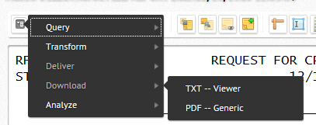

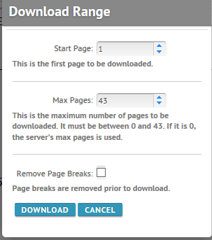

Paging through report –
The below buttons will page you through the report and tell you what page of the report you are on and how many pages there are. You can hover over the icons to view their function.

Searching on Text –

Enter value in Find Text box then hit Enter or click down arrow. Hit down arrow to find next occurrence or up arrow to find previous occurrence.

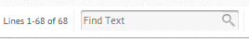

Adding Notes –

NOTE: This option may not be available to all. If you have a need for this option, send EMAIL to ProductionControl mailbox.
The below set of icons relate to Notes. You can hover over the icons to view their functions.

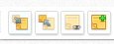

You can add a note by clicking on the 4th icon. A window will open allowing you to add a note and Save.

[IMAGE THAT SHOWS AN ANNOTATION BEING ENTERED ON A REPORT]

A note icon 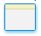will now appear on the report. You can click on this icon to view note.

[IMAGE THAT SHOW THE NOTE ICON ON THE REPORT]

When doing a Search, reports with Notes will have a Note icon to the left of the Title.

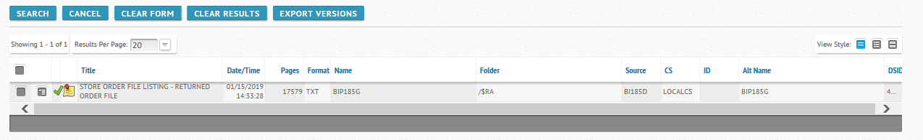

My Pages –

If you have reports that you view on a regular basis and would like them to appear on your initial Welcome page, you can Add to My Pages. While doing a Show Versions, click on the star icon then click on Add to My Pages.

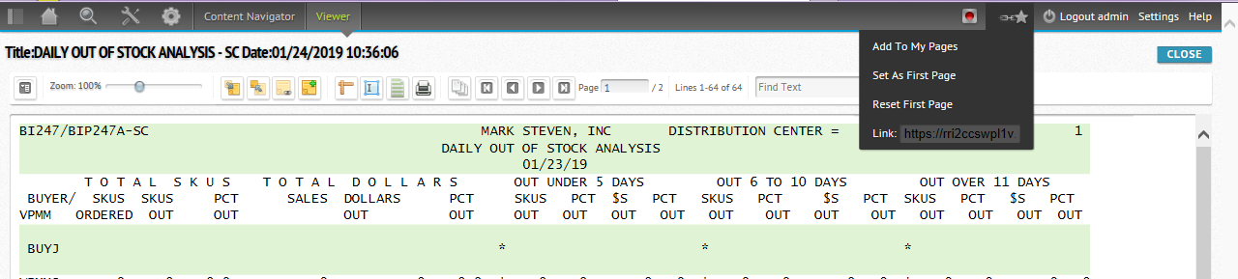

A window should appear as below (Name displays as Show Versions) -

Change the Name to a description that is meaningful to you (name must be unique). Click Save.

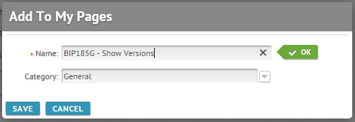

When you logon, this report will now show up in your My Pages on the Welcome page.

[IMAGE OF HOME PAGE WITH THE ADDED REPORT UNDER “MY PAGES” SECTION IN MIDDLE OF PANEL]

You can delete reports from My Pages by clicking on the icon to the right of the report.

You can change the name of the report by clicking on the icon to the right of the report.

First Page –
If you would like to change the ‘first page’ you are presented with, at any time you can click on the icon and click on Set as First Page. A window will pop up saying First Page Updated. When you log out and log back in, you will be presented with the page you saved.

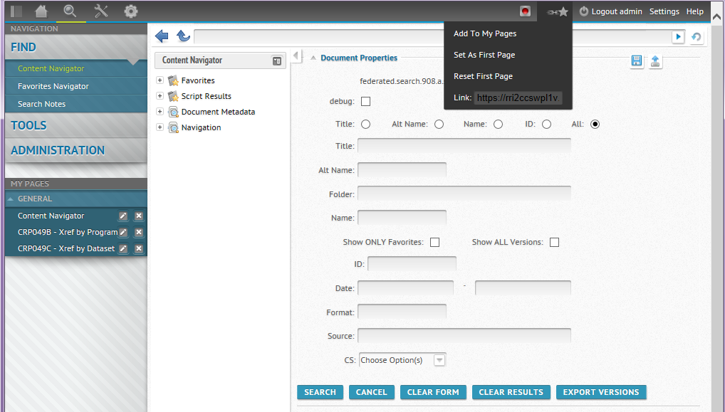

If your First Page is not what you want/expect, click on the icon and click on Reset First Page.

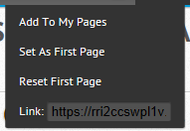

Processing Multiple Reports –

While in Show Versions, you can process multiple reports by selecting multiple reports (check boxes on far left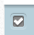). You will notice a new box 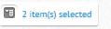 appear to the right of the line showing how many versions are available. If you click on the box then hover over the options, you can view/download/print (PDF) all reports selected as one.

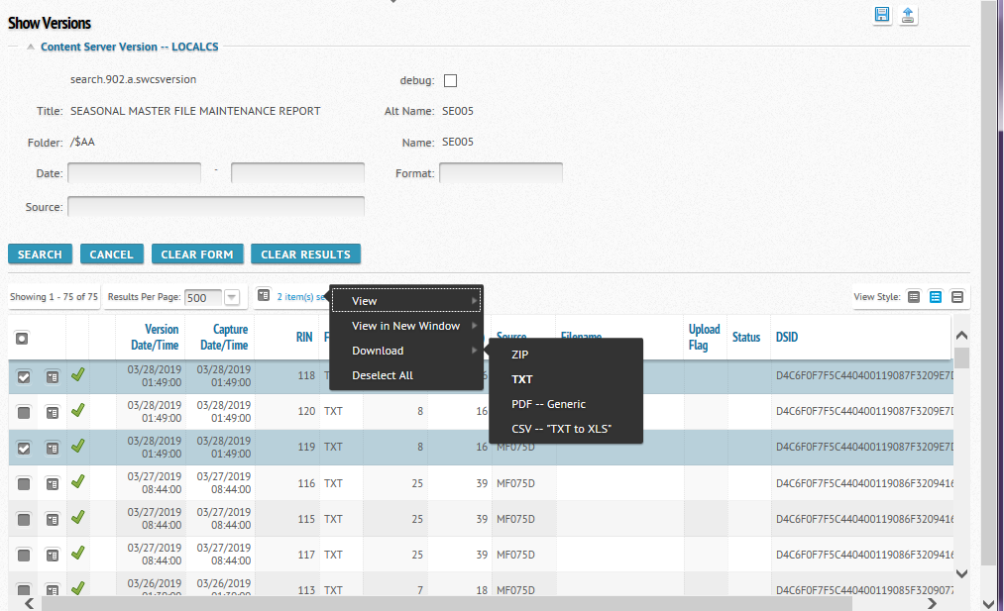

Exiting report –

Click CLOSE button

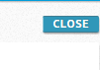

Questions may be directed to:
- [NAME] [PHONE NUMBER]
or you may email either:
- [EMAILADDRESS] or
- the _______________________mailbox.

