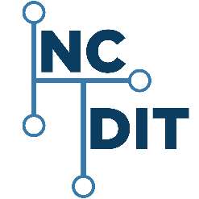 | NORTH CAROLINA  DEPARTMENT OF INFORMATION TECHNOLOGY  STATEWIDE IT PROCUREMENT OFFICE  https://it.nc.gov/resources/statewide-it-procurement-office
Request for Clarification
Solicitation Number: | [Insert solicitation number]
Solicitation Description: | [Insert description]
Solicitation Opening Date and Time: | [Insert solicitation opening date and time]
Addendum Number: | [Addendum number]
Issue Date of Request for Clarification: | [Issue date of this request for clarification]
Purchasing Agent or Contract Specialist: | [Name]  [Enter email address | Telephone number | Fax number]

- Return one properly executed copy of this clarification request via [email to xxxxx@xxx OR fax to ###-###-####].
Clarification Response Due Date and Time: [##:## am/pm ET, Weekday, Month Date, 20YY]
- [Agency must list items for clarification. Reference applicable page numbers, item numbers, paragraphs, etc., of solicitation and/or Vendor offer.]

Sign Clarification:
Offeror:
Authorized Signature:
Name and Titled (Typed):
Date:

